Pharmacy management system

 system that stores data and enables functionality that organizes and maintains the medication use process within pharmacies

Our project provides a service for pharmacies to work with products and medicines easily while providing an appropriate database

In addition, it provides reports to serve managers

* The project starts with:

By logging in to the program, with the possibility of access that is determined by the admin

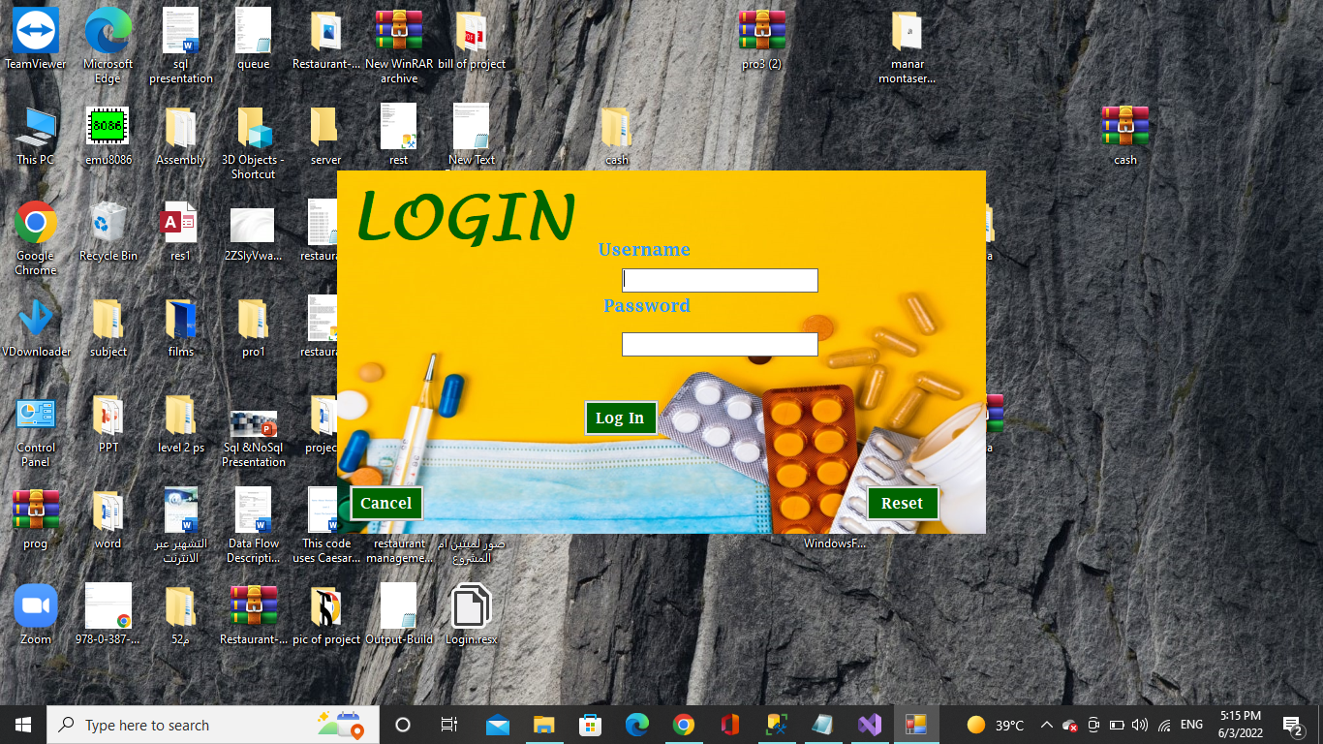

* The different processes:

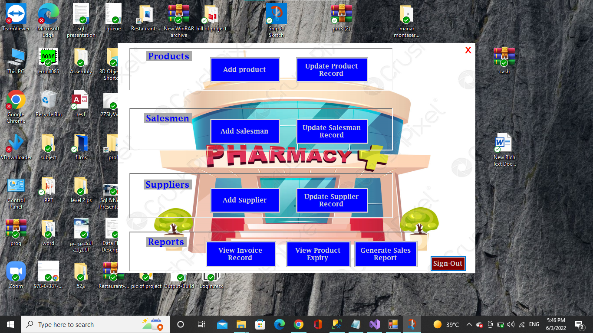

* The program provides a form for the salesman to enter the products and store them in the database of the program to work on the various operations:

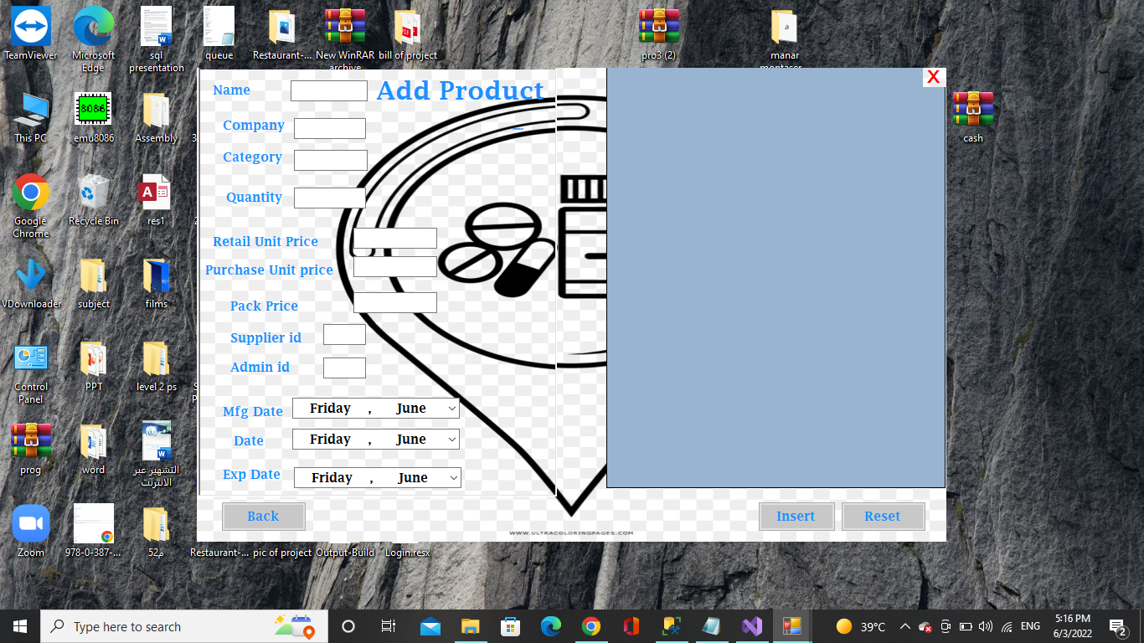

* The program provides a form for an admin to enter salesmen and store them in the database of the program to allow them to access the data

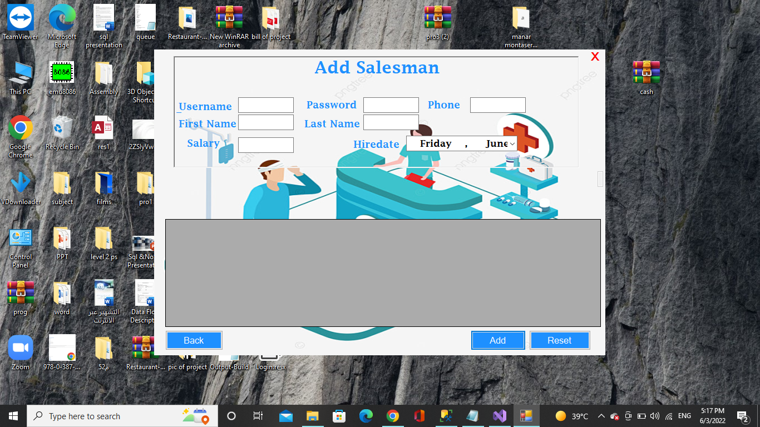

* Then the salesman makes sales orders for reference and builds a report on them

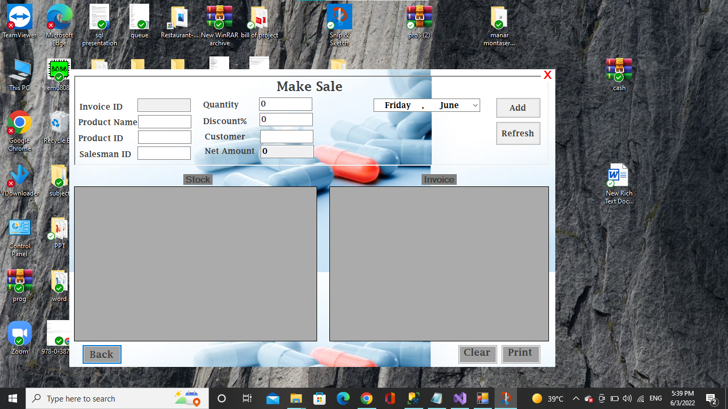

حفظ الترجمة

* The program will provide work with expired products by entering the production date and expiry date, thus deleting them from the products available for sale.

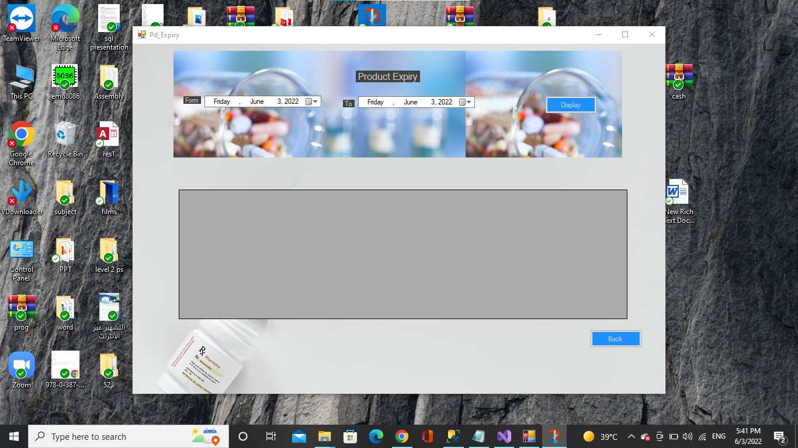

حفظ الترجمة

* The program will provide work with expired products by entering the production date and expiry date, thus deleting them from the products available for sale.

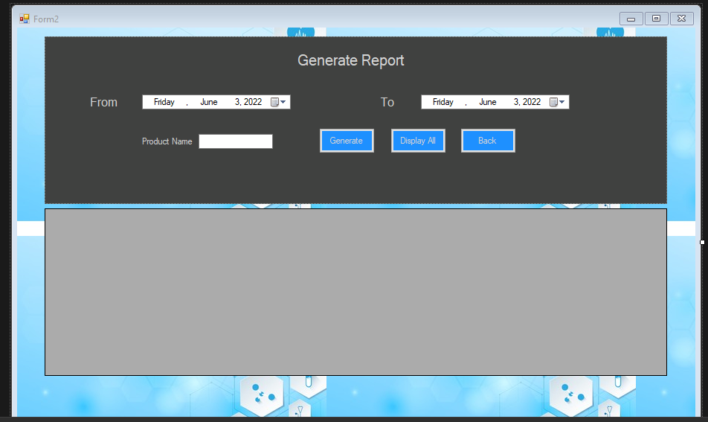

* Editing is also available

